Macintosh HD:Users:justin:Desktop:Screen Shot 2017-12-04 at 2.04.41 PM.png

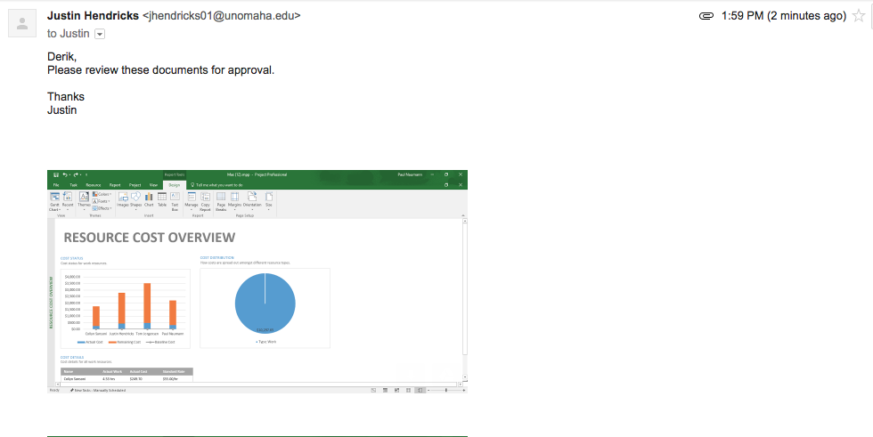

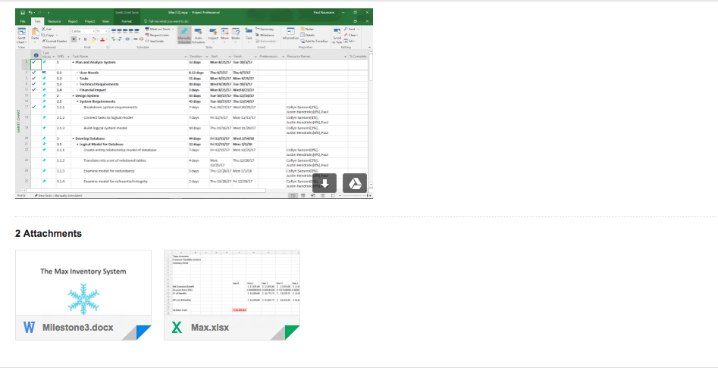

Macintosh HD:Users:justin:Desktop:Screen Shot 2017-12-04 at 2.07.43 PM.png